**Newcastle Libraries Online Maker Tutorial:**   
**Magical Mandalas**  
**With Bree Cunningham**

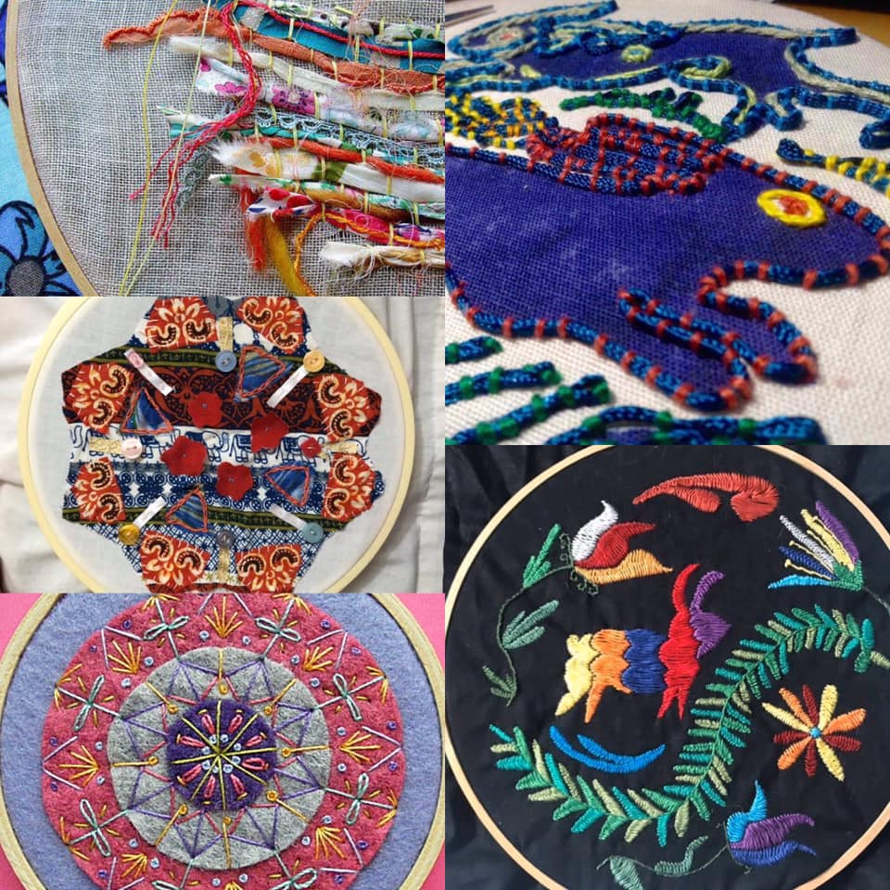

**Materials List and Step by Step Instructions**

**Materials List**

* Embroidery hoop 25cm
* Embroidery needle
* Stranded cotton embroidery thread
* Plain colour fabric 30cmx30cm
* Variety of secondhand fabric (old clothes work)
* Scissors

*Optional*

* Pencil (or water soluble fabric pen)
* Pins
* Buttons and charms
* Craft glue

**Step by Step Instructions**

Mandalas have been used in Buddist cultures for centuries. They are made up of complex geometric patterns and shapes. Usually created using coloured sand or paint.

Mandalas are used as a focus for meditative purposes, so the slow creation process is important. How the mandala looks at the end is NOT the point, it is the journey of creation. Using the act of free form creation to focus your energy and mind either on a calming state or to answer specific questions you have about your own life.

Mandalas can be made as individual tiles or as multiple tiles sewn together later to create a larger project. If you would like to create a larger project, I suggest using a feng shui map to help guide each mandala, in both area of focus and colour such as:

**Feng Shui Map**

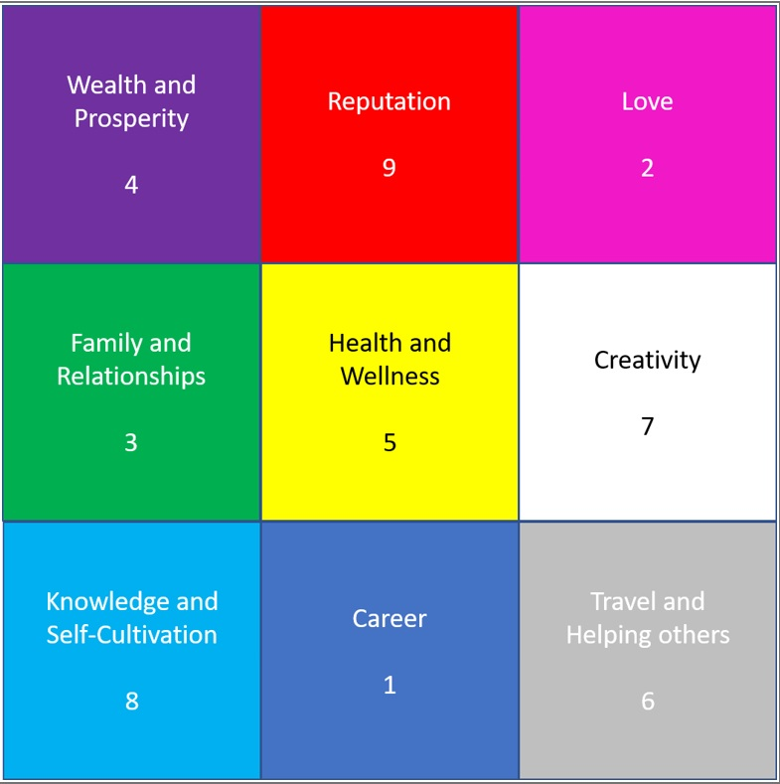

Of course, you can just make a free-from mandala without the focus on a life area as the act or creation is great to help relaxation and calming of the mind.

**Step 1 - Meditation**

The first step is to relax and meditate to focus our minds or a specific area of your life (such as in the feng shui chart) or just to bring your mind into focus of creating something new*.*

Find a quiet and comfortable space. Close your eyes and take a few deep breaths. You can use a guided meditation from YouTube or an app to help you to relax, Meditating will help put you in the right frame of mind and help you focus on any issues you would like to identify and explore through creating the mandala. Otherwise, just taking time to relax helps as well.

**Step 2 - Set up**  
  
Put the plain fabric square in the embroidery hoop. Hoops are either pinch close or screw close. Just make sure the plain fabric is taut. Place all items you will be using within reach.

**Step 3 - Centre Mandalas are made up of 3 main sections**

The Outer circle of the Mandala represents the outside world. The inner circle represents a map of the journey *w*e must take to overcome our issue.

The centre of the Mandala represents a secret meaning. This usually is the centre of your issue or an abstract representation of yourself. A balance between body and mind. For this example the centre meaning for me is Family and Relationships with a green colour palette as per the feng shui map.

To make our mandalas we will start in the centre and work our way out. Start by selecting a scrap piece of fabric that you like and cutting out a shape. It could be a circle or a splat or a square.

You can cut out a shape that works as a background and covers most of the space of the plain fabric in your embroidery ring or something small that works as a centre shape.

If you are using a background shape make sure there is at least 2 cm around the edge from the embroidery hoop so you can access the edge to stitch down later.

At this point in your mandala we are just cutting out our fabric shapes and laying them onto our base. If you want to pin the shapes into place you can but you should be ok to just lay everything onto the plain fabric to get a sense of the shapes to start.

**Step 4 - Inner and Outer Circles**

Next we can look at the inner and outer circles. Again selecting a scrap fabric you like cut out some shapes and place around the centre. You can use your pencil or water soluble pen to draw the shapes on the fabric before cutting. Or you can cut out a template on a piece of paper so that you end up with the same shape multiplied.

I prefer to cut freehand. And if I like the shape I will use the first shape as the template. If you don't like the fabric or the shape, just try again. You can change any of these elements as much as you like, whenever you like.

As you cut out your shapes, place them around the centre, the inner circle and outer circle. Repeat shapes as desired or just add random shapes all over the work space.

**Step 5 – Thread**  
  
Once you have cut out your shapes and placed them, you can either pin the shapes in place or you can remove loose fabric from your working surface and add as you stitch.

To stitch the fabric into your mandala, use 2 strands of thread.

To get a strand cut a length approx a metre from the skane. From seperate the six strands at one end into a fan. Select 1 strand and gently pull the strand from the cut length. Repeat to get a second strand.

Use both of these separated strands to thread your needle.

Use more strands for a bolder stitch or use one strand for a litter stitch. Feel free to experiment while making your mandala. In general however, using two strands is standard practise.

Don't split the strands if you are using perle cotton. If you are using general sewing thread, you can double the thread over. Please note that general sewing thread doesn't twist together like the stranded embroidery thread and will look sparse when stitching with more than a double thread.

**Step 6 - Needle**

To thread a needle pull the two strands through the needle. Keep a short end and a long end. On the long end, tie a double knot. Make sure the short end is not too short, but don't double the thread over.

**Step 7 - Stitches**

There are quite a few types of stitches you can learn to add flair to your mandala. But all stitches are based on the following four principles:

1. Straight stitch - put the needle through from the back through all layers of fabric. Pull the needle and not the thread through the fabric. Then put the needle through all layers of fabric. Stitches can be any length but it's best to keep your stitches short and uniform. I would suggest a stitch length of about 0.5mm. Repeat.

2. Running stitch - pull the needle through from the back through all layers of fabric. Pull the needle from the top over the edge of the fabric creating a diagonal stitch. Repeat.

3. Backwards stitch - create a straight stitch as above. On the second stitch, however, instead of making the stitch move forward, place the needle in the same hole as the end of the previous stitch. This will form a continuous line. Repeat.

4. Blanket stitch - create a straight stitch but don't pull the thread tight. You should have a small loop of thread sitting on the surface. Bring the needle up through the fabric, in line with the second hole and bring the needle through the loop and pull to tighten. Repeat.

With these four basic principles you can create leaf stitch, satin stitch, feather stitch, seed stitch. And of course, making a free form mandala you can create any random stitches you desire. Just remember to tie a knot at the beginning and end of your stitching process and to catch all layers of fabric as you sew.

**Step 8 - Tying a Knot**

To tie a knot make sure to leave enough thread to get the needle through the fabric, and to be able to twist the needle through a knot. The best length is about 10cm. Once you have tied the knot you can cut the excess thread.

**Step 9 - Layering**

So now that you have placed your shapes and know how to stitch, get stitching! Start from the centre of the mandala and work your way out. Stitch along the edge of the fabric shape or stitch through the middle. If you want to add texture you can simply tie the fabric together by putting the needle through the top of the fabric, bringing the needle up and tying a knot.

Change colours of threads when you desire. If you don't like how a stitch turned out, undone it and start again. Most importantly, take your time. Create your mandala in a calm and relaxing space. Focus on the work you are doing without the distraction of the outside world. Focus on the area of your life that the mandala relates to. Hopefully quiet inner thoughts will reveal themselves to you as you stitch. Or you could be like me. I create a strong association of my thoughts and feelings while I'm stitching and once I'm done, every time I look at my mandala I am reminded of them.

**Step 10 - Embellishments**

Once you have stitched all your shapes onto the work space, you may want to add embellishments. These could be ribbons, buttons, trinkles, pressed flowers, shells, etc. You can either stitch these into the design of glue them with fabric glue. Currently fabric glue is often called slime glue, but it is the same stuff.

You may even want to add further details by painting onto your mandala. Just remember that fabric is absorbent, so it's always best to test your paint on a separate piece of fabric first. You don't need to use specific fabric paint unless you will be adding your mandala to something that will be washed.

Now your mandala is finished you can remove it from the embroidery hoop and use it to make a cushion, use as a patch on a jacket, make more mandalas and create a blanket, or simply leave the mandala in the embroidery hoop, trim the excess edges and hang on your wall.

I hope you enjoyed Magical Mandala making. Thank you for joining in.

### **For more inspiration you will find Bree Cunningham on:**

### Web address: [www.laughingmyartsoff.com.au](http://www.laughingmyartsoff.com.au/)

Facebook: <https://www.facebook.com/LaughingMyArtsOff>

Instagram: <https://www.instagram.com/laughingmyartsoff/>