**Newcastle Libraries Online Maker Tutorial:**   
**Ceramics by Teval**  
**With Teval Guner**

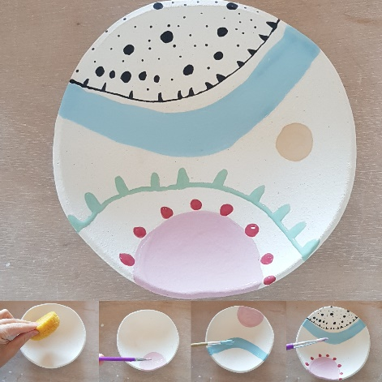

**Materials List and Step by Step Instructions**

**Materials List**

You will be provided with the following materials to decorate your plate:

* 1 bisqued ceramic plate
* 4 tubs of glaze
* Brushes

NOTE: After registration for this tutorial you will be send an email with information about collecting the materials directly from the artist (in Newcastle).

**Step by Step Instructions**

The plate to be glazed is hand built and its first firing (known as bisque or biscuit firing) is already done. So it is ready to be decorated by applying layers of glaze.

Once the decoration is completed and the layers of glaze are dried, a clear glaze will be applied which will make the plate ready to be fired to a stoneware form which is very tough and practical.

For a positive result, it is quite important to keep everything nice and clean.

Step 1: On a piece of paper create your design for the inside of the plate noting that there will be no glazing applied to the outside of the plate.

Step 2: Wipe your starting bisque plate with a damp cloth.

Step 3: Roughly visualise your design on the plate and start glazing the first layer.

Step 4: Once the first layer is dry, glaze over the same design with the same colours.

Step 5: After the second layer is dry, glaze over the same design for the third and last time.

Step 6: After three layers of glazing, leave the plate to dry.

Step 7: Apply a clear glaze for the plate to be food safe and to have a shiny finish.

Step 8: The plate is now ready for the final firing which will adhere the glaze material to the plate.